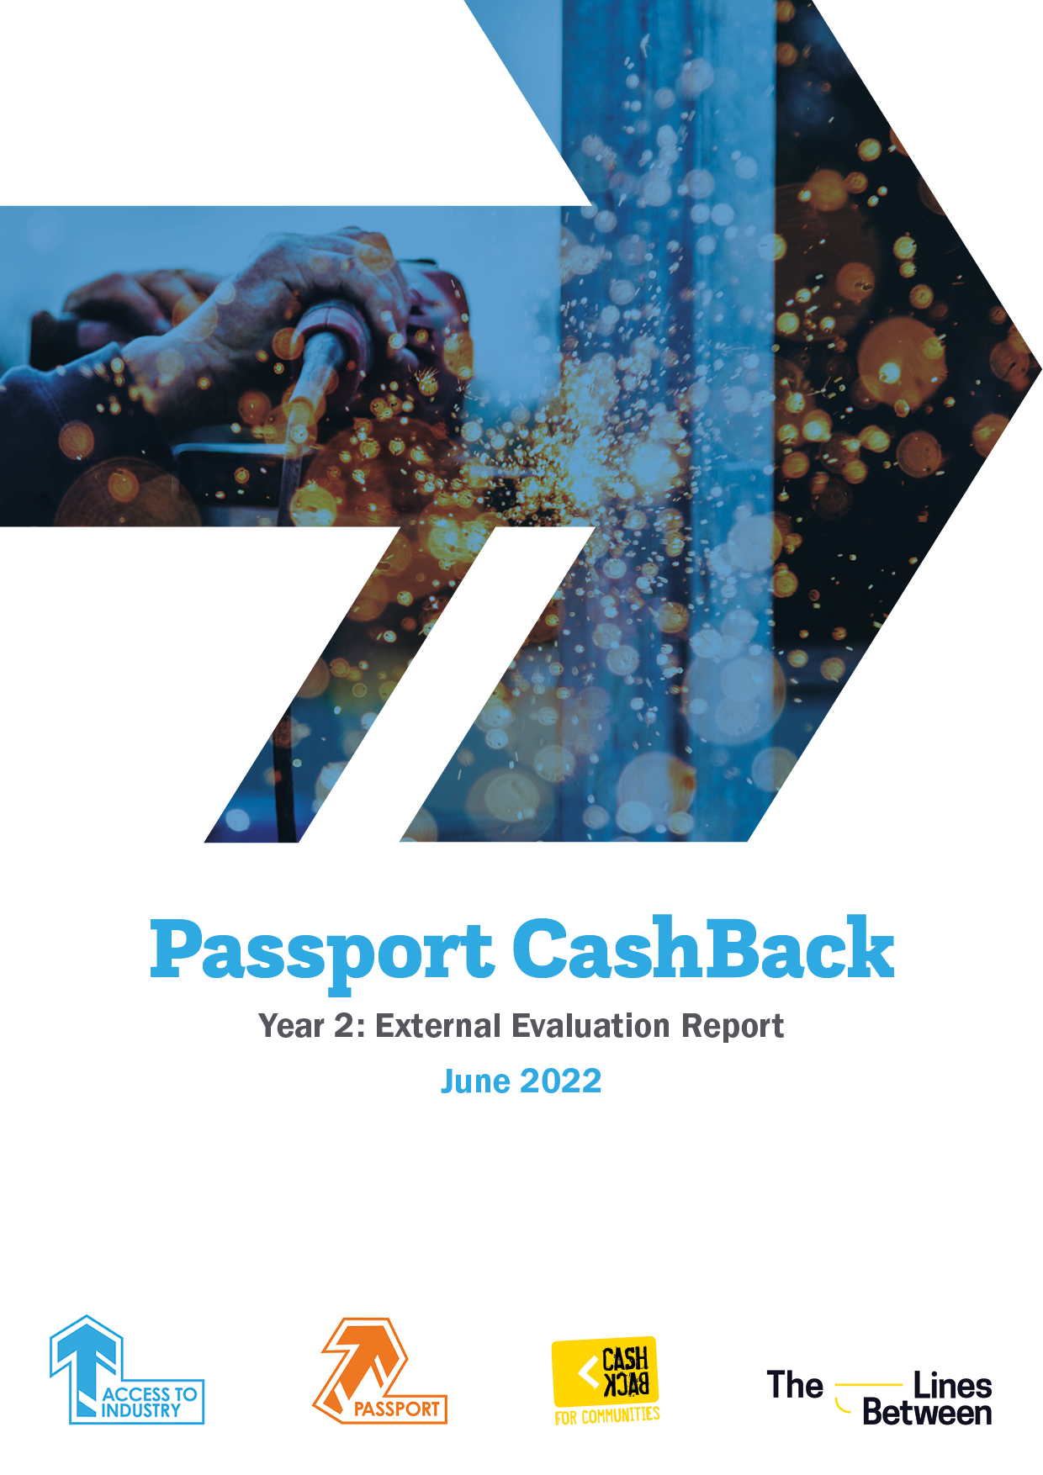

1. Introduction 1
2. Evaluation Methodology 5
3. Impact on young people 7
4. Project development – Year 1 to Year 2 analysis 21
5. Conclusions and looking ahead 22

Introduction
Passport Cashback
- CashBack for Communities is a £19m national programme which funds a range of positive activities for young people between the ages of 10-24. The Scottish Government funding uses money seized from criminals to invest in projects for young people who face disadvantages. CashBack for Communities began in 2008 and is now in Phase 5 (from 1 April 2020 to 31 March 2023).
- In Phase 5, Access to Industry was awarded £500,000 for Passport CashBack, to provide training and employability support to young people aged 16 up to 23 in HMP & YOI Polmont. Passport CashBack aims to increase their employability skills before liberation and continues to support them after that point.
- The project views all young people in Polmont as having the potential to build skills towards employment, regardless of the length or type of sentence, gender and locality. Connections are made with young people while they are in HMP & YOI Polmont, with contact maintained throughout their sentence. Caseworkers develop an Action Plan with each young person reflecting their interests and skills and encourage young people to engage with other activities and services to access the most comprehensive support before liberation.
- On liberation, through the continued contact with a caseworker, Passport CashBack provides further support to young people, offering opportunities in the community to find and secure jobs, college and training places. Caseworkers also work with young people to explore other opportunities to engage with support services and manage issues such as the disclosure of convictions.
- Much of the work of Passport CashBack is delivered by a CashBack Coordinator who works full-time within Polmont. They coordinate programmes for young people, focussing on training, employer engagement and sector-based qualifications, notably from the construction and hospitality industries.
- Key targets for years 1-3 were for Passport CashBack to:
- engage a total of 280 young people;
- achieve 168 accredited training certificates;
- support 224 young people to increase their wellbeing;
- assist 153 young people to positive progression post-liberation;
- support 81 young people to move into employment or further education; and
- for 72 young people to engage with other providers.
- By the end of Year 2, a total of 222 young people had participated in Passport CashBack, an impressive achievement despite pandemic-related restrictions to staff capacity and working practice.
Participant profile
- Passport CashBack effectively reached the intended target groups that CashBack for Communities seeks to support; the majority (62%) of participants live in the areas of highest multiple deprivation. Engagement with the programme spanned the higher age ranges, with the vast majority (89%) in the 19-24 age bracket. Reflecting the prison population in HMP & YOI Polmont, almost all participants were male (98 %)
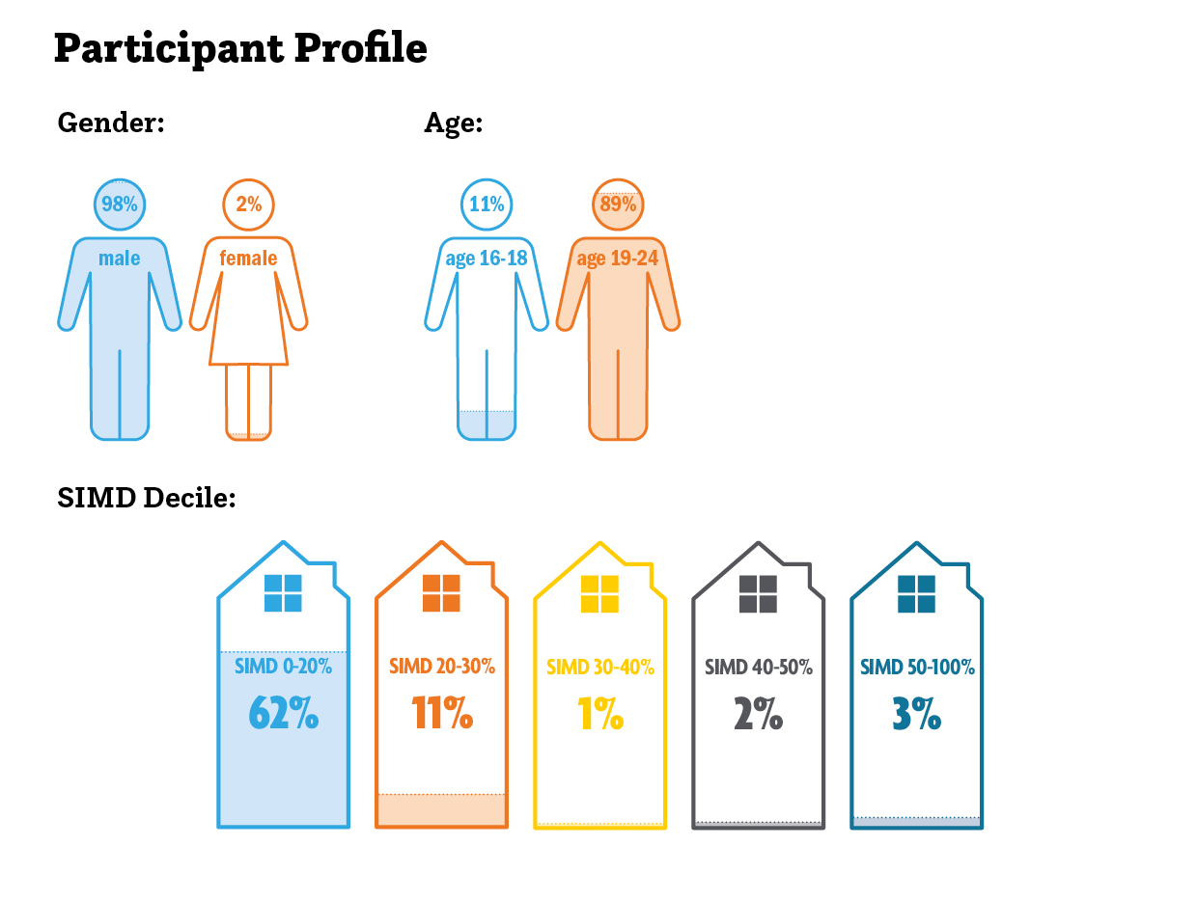
Delivering Passport CashBack in the context of legislation changes and the pandemic.
- The project has been operating during a time of significant legislative and practical change which are worth highlighting.
- Based on evidence that short custodial sentences are less effective than community sentences the presumption against short sentences (PASS) was extended from three months or less, to twelve months or less, by the Presumption Against Short Periods of Imprisonment (Scotland) Order 2019. This has meant that young people who are given a sentence of less than a year are not being sent to prison, with a resulting impact on the number of young people in custody and of those who may have been more employability ready.
- Passport CashBack involved delivery in HMP & YOI Polmont, a relatively constrained environment with robust systems and tight procedures. For example, any arrangements to meet a group of young people in Polmont requires various checks about whether a particular group of young people are considered safe to be together, whether they are at the right level to work together and if any individuals are currently on any punishments.
- However, with the arrival of COVID, substantially more rigid restrictions were put in place. In the words of the Co-Chief Executive of Access to Industry, “our aspirations and plans were taken away.”
- The pandemic’s impact is explained below; a vital reference point for all the project activity described in this report:
- The programme model featured three caseworkers to deliver work one-to-one with young people during their time in Polmont and once liberated into the community. However, due to the pandemic, this was re-assessed in Year 1. One full-time caseworker began in September 2020 and a second followed during 2021.
- During this time, the project faced significant restrictions – notably because of a halt on outside agencies coming into Polmont coupled with infection control measures within the building, which limited the movement of prisoners and restricted mixing. This combination of factors substantially reduced in-person contact time between caseworkers and young people.
- There was no in-prison access for Passport CashBack staff for the first five months of the pandemic, and after that it was restricted to a day a week representing a severe limitation on time.
- In addition, there were physical restrictions, with no access to the halls area, and with young people needing to be brought to a certain point by prison staff, at a time when the prison workforce lacked capacity to do so. The emphasis on reducing traffic for infection control purposes, to keep young people and prison staff safe had substantial knock-on effects to service delivery. This meant that the complement of caseworkers planned for was not appointed because the caseloads were reduced.
 | “We had aspirations to deliver softer employability access in the halls for young guys less motivated to come to the employability areas in the prison – that would be with the young guys furthest removed – we’ve not been able to do that.” [Passport CashBack Co-ordinator]
- The prison population of young people which Passport Cashback anticipated working with reduced from 485 to 283 when the decision was taken to release low-tariff offenders into the community. Many of these young people would have been expected to be suitable clients for Passport CashBack – low tariff, fewer restrictions, and potentially easier to employ. Those remaining were more complex, longer sentenced clients.
- Other changes to the anticipated way of working involved the level of engagement available from statutory services, with their staff having been instructed to work from home. Typically, Passport CashBack staff would have been expecting to arrange partner meetings in prison, where young people could be introduced face-to-face to other support agencies, but those opportunities were curtailed.
- Meanwhile, in the community, there were restrictions on access to safe spaces like community centres where caseworkers hoped to meet clients.
- In addition, the expectation of supporting young people to meet employment agencies, employers or other support services in person was reduced as organisations were no longer working in that way. While many had shifted to digital engagement, often young people were not comfortable with digital meetings; either being unused to this form of communication or sometimes having undiagnosed needs, which meant they struggled with that format. Meeting in person or by phone were preferred.
- This combination of factors hampering transitions resulted in an increased volume and more intense workload for Passport CashBack caseworkers. For example, they were often called on to support young people with welfare rights or health matters. Ordinarily, the service would expect to support people in a holistic way, but staff report that the level of need evident in young people was heightened because other support was not available.

Evaluation Methodology
- As a condition of receiving CashBack for Communities funding, Access to Industry was required to commission an external evaluator to gather evidence about the programme and report on progress towards programme outcomes agreed with CashBack for Communities.
- The Lines Between, an independent social research agency, was selected to deliver the evaluation, which has involved undertaking primary research with those connected to the programme, reviewing and analysing secondary data and producing an annual report and quarterly case studies.
- The Lines Between was supported by caseworkers to contact young people who participated in Passport CashBack while serving their sentence and post-liberation.
- A discussion guide was developed for these evaluation interviews. The discussions provided young people with an opportunity to reflect on their experiences of support from Passport CashBack and share examples of impacts, including contributions to aspirations and outlook. During interviews, connections between their involvement with the project and target outcomes were fully explored.
- Each interview was recorded, transcribed and written up as a case study using the first-person style, to ensure that young people’s voices and views on the project were clearly articulated.
- Where possible, a stakeholder interview linked to each young person was also undertaken to give an additional viewpoint of the young person’s current situation, any progress made and personal development observed within the context of the CashBack outcomes.
- In each case, the identification and involvement of stakeholders relied on the young person having other people in supportive roles, and individuals being willing to take part. If young people did not have other supportive or professional relationships, we sought the perspective of the Passport Cashback caseworker involved.
- The aim was to carry out one paired case study (presenting the views of a young person and stakeholder) each quarter. By the end of Year 2, 5 case studies were written (two in the last quarters of Year 1 and three during Year 2). Another case study was proposed but not developed as the young person’s circumstances changed which affected their ability to participate. One stakeholder from a social work team committed to taking part but later withdrew because of revised local authority policies on sharing information.
- As far as possible, the evaluation team sought to develop a range of case studies representing young people who were moving into work, college or exploring personal development options. The case studies also represented young people with a range of offending histories and backgrounds.
- The evaluation proposal included visits to Polmont and engagement with young people there, but COVID restrictions prevented this. The case studies have generated evidence from five young people, four Access to Industry staff (including two caseworkers), and two external stakeholders from Action for Children and Police Scotland (Public Protection).
- Access to Industry uses their own model of self-evaluation. This includes using feedback forms for training events and the outcomes star approach to explore ‘before and after’ perspectives. At the start of phase 5, staff shared these approaches with The Lines Between to confirm the tools and materials were fit for the purposes of self-evaluation.
- Researchers from The Lines Between also analysed secondary data sources, including Access to Industry’s quarterly reports to Inspiring Scotland and the Scottish Government.
- The scorecard data presented throughout chapter 3, which indicates whether the CashBack for Communities outcome targets were met, is based on self-evaluation data gathered from young people who have engaged with Passport CashBack.
- The remainder of the report is structured as follows:
- Chapter 3 describes the impact of Passport CashBack on young people and shows progress toward programme outcomes.
- Chapter 4 reflects on the delivery of the project, describing highlights and challenges.
- Chapter 5 presents a short conclusion.

Impact on young people
- This chapter explores the impact of Passport CashBack on participants, drawing on self-evaluation data gathered by the project and on qualitative research undertaken with young people and stakeholders.
- The evidence is structured around the six programme outcomes agreed between CashBack for Communities and Access to Industry; results are shown below:
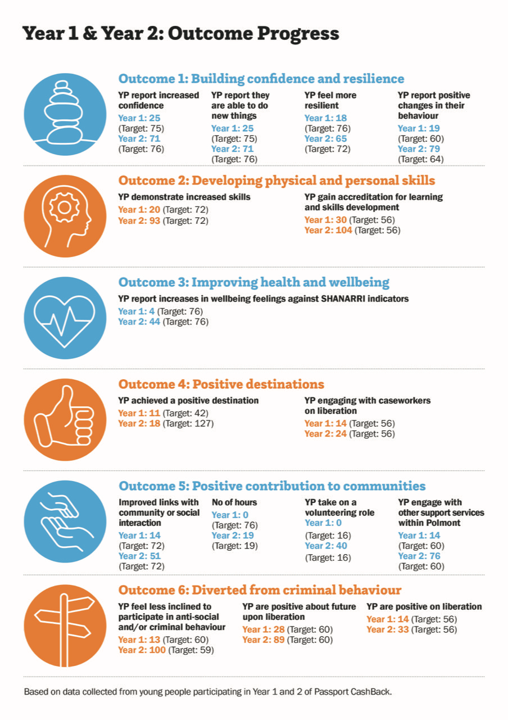
Outcome 1: Young people build their confidence and resilience, benefit from strengthened support networks and reduce risk taking behaviour
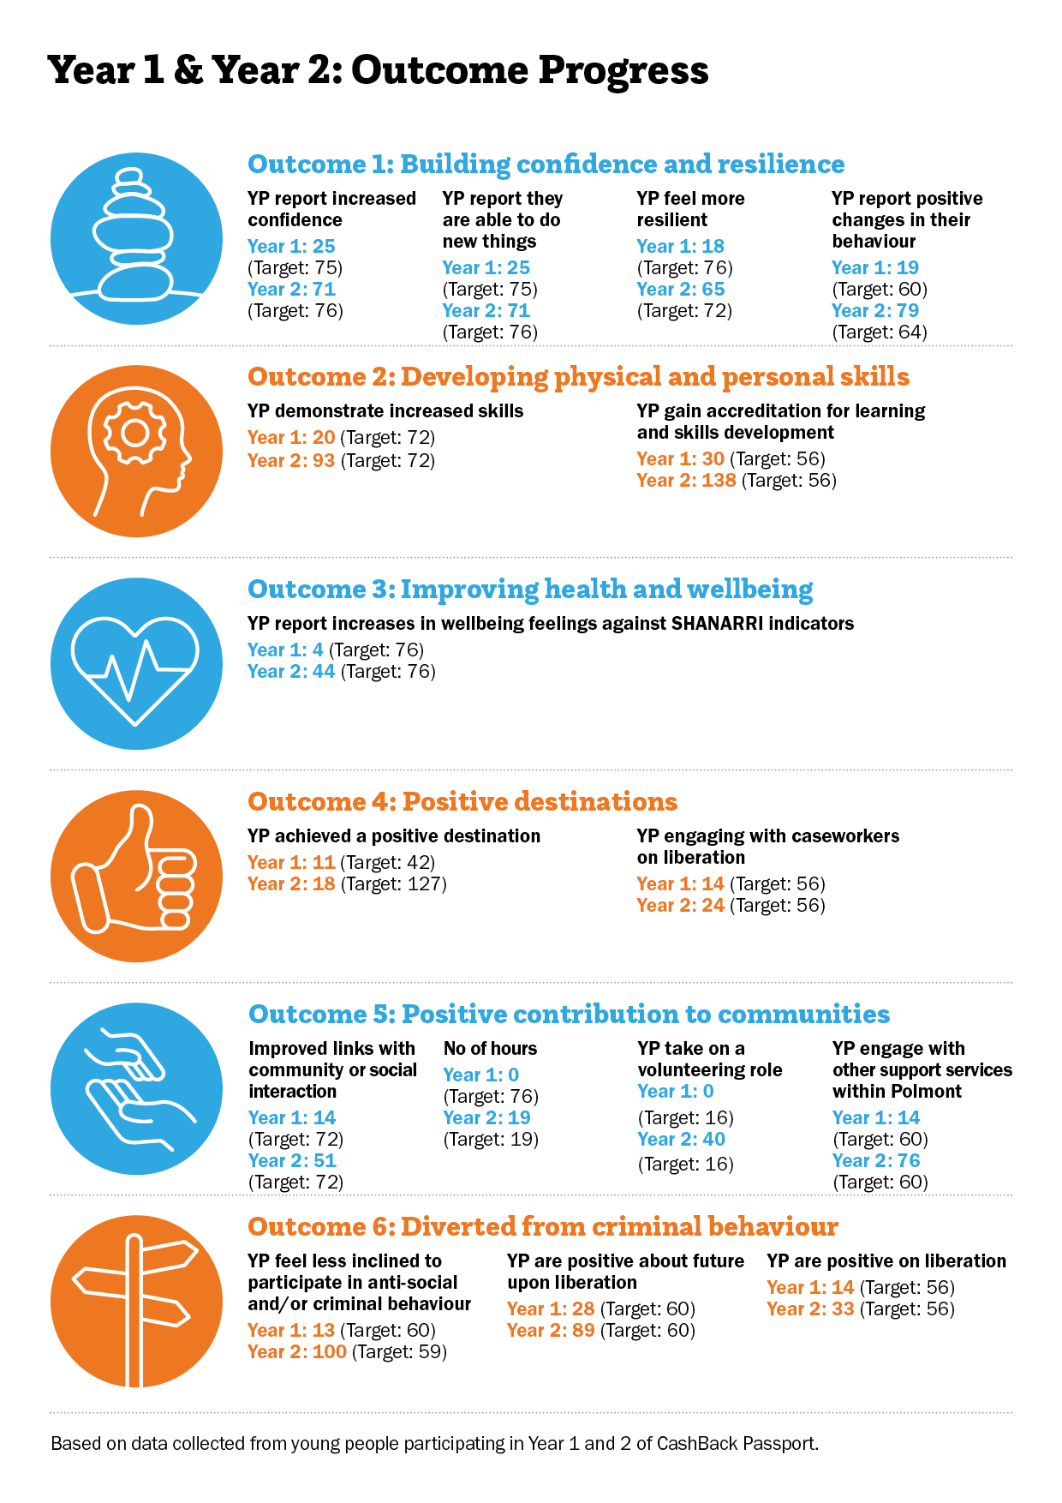
- Evaluation and monitoring data collected from young people shows Passport CashBack’s impact on young people’s confidence and resilience. After two years, Passport CashBack has achieved 60-68% of its targets for all but one of the indicators, with the highest figure representing reporting positive changes in young people’s behaviour. The figure is lower (53% of target) for stakeholder reporting changes in behaviour.
- Analysis over the two years shows that the figures from Year 1 and particularly the first quarters of that year, are the main negative influence on the overall figure, with the context for this explained in the previous pages. Across the four indicators, the scores increased during Quarter 3 of Year 1 and then were reached and exceeded by the end of Year 2. The Year2 figures for the four indicators are between 84% and 123% of target, compared with the range in Year 1 (24% - 33%).
- In the evaluation interviews, young people and stakeholders identified the changes in confidence and resilience that they attributed to support from Passport CashBack.
“[At the start] He did score himself quite low on confidence and self-esteem and being able to communicate feelings, to be assertive. His confidence has built in this last month and a half that I’ve been working with him. I think that’s down to trust and having somebody that calls him weekly that asks him how he’s doing.” [Katy, Caseworker, Case Study Y1Q3]

“Last year to this year I’ve changed a lot, I’m not as shy anymore, I’ll stand up for myself if I need to... I want to change my life and get a job, I want to move on... No more trouble; this is me getting my life sorted.” [Andrew, young person, Case Study Y1Q3]
- There is a consistent message that having a caseworker taking an interest in, and encouraging a young person, while supporting them with practical tasks, creates a safe foundation which enables opportunities to be considered, and for motivation and self-belief to grow.
“To have that partner [organisation] who can go in or even speak on the phone just to say, “We’re here, this is what we could do, this is what we can offer,” is very, very helpful. That just gives a wee bit more confidence and more clarity – what’s going to happen in the big bad world.” [Keith, Public Protection, Case Study Y2Q2]

Greg was an individual who lacked a lot of confidence... having appointments with Rosie has helped him a lot and given him a bit more of an awareness... he’s got his mind set on other goals there as well... That’s really good for him because in the time that I’ve been dealing with him, that’s a massive step for him, because he hasn’t had the confidence – he would never have been able to focus, looking even a month or two months in advance. [Keith, Public Protection, Case Study Y2Q2]
- Young people also reflected on changes to their confidence, highlighting the supportive delivery style, and how that impacted their ability to engage with opportunities and change their outlook.
“My mental health is still a bit crap but I’d say my confidence has gone up with job interviews – it’s been boosted a wee bit so that’s a plus, probably with Rosie helping me out, giving me questions beforehand that you’d get asked and stuff like that.” [Greg, young person, Case Study Y2Q2]

“I've grown in confidence with thinking about other stuff, because for a long time I was totally closed off to everything else - cooking was my comfort blanket. But I’m coming to a place where I feel like I would probably try most things ... I've sort of opened my eyes.” [Lucas, young person, Case Study Y2Q4]

Outcome 2: Young people develop their physical and personal skills
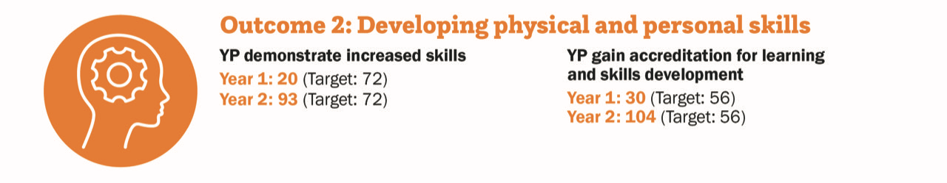
- The data demonstrates Passport CashBack’s success in supporting young people to develop skills. Across Years 1 and 2, a total of 168 young people increased their personal skills by achieving accredited learning and exceeded the two-year target of 112 by 50%. In the first two years, 113 young people reported an increase in skills which represents 80% of the target being reached.
- The fact that the project is over target for accredited learning despite working with fewer young people than anticipated is as a result of individual young people accessing more qualifications per person than expected.
- Young people can gain qualifications in prison for different industry areas, notably construction and hospitality, with examples including:
- Construction Skills
- CSCS – Construction Site Certification Scheme
- TIGERS – incorporating five different construction industry recognised certificates, including CAT&Genny (locating underground services for cable avoidance); Manual Handling; Asbestos Awareness; Vehicle Marshalling and Abrasive wheels.
- PASMA – Prefabricated Access Suppliers' and Manufacturers' Association – accreditation in assembling, moving and dismantling low-level equipment and mobile towers
- Environmental Waste – environmental awareness linked to construction sites.
- Hospitality
- World Host Training- principles of customer care
- REHIS First Aid at Work
- REHIS Food Hygiene

“[Caseworker] was helping me try and find some stuff. She really helped with getting my CSCS Card (Construction Skills Certification Scheme). You have to do a couple of days’ course, and then I done my test afterwards... I passed it the second time. She organised a lot so that I now have my qualification and my card so that’s good.” [Stuart, young person, Case study Y1Q4]

“I've benefited along the way, in a few different ways. I've done the Tigers Programme, which is basically a construction programme. I’ve done my RCC card - a recycling compliance card... a relatively new qualification but very good to have now... I’ve also done my elementary food hygiene which is ideal for my line of work. I've done so many things - WorldHost programme as well - a hospitality-based thing. [Lucas, young person, Case study Y2Q4]
- Young people can also undertake assessments such as psychometric tests or access personal development courses on liberation. These are ways to gain skills, knowledge and certification, and become more aware of their strengths and how these might link to opportunities and choices.
“We done a psychometric test and it was really really interesting... I found things out about myself that I don't think I would have noticed.” [Lucas, young person, Case study Y2Q4]

Extract from case study: In July 2021 Rob completed his SQA Personal Effectiveness 3 qualification/certificate. He was also awarded an Access to Industry Cashback Certificate of Admiration for the weekly commitment and resilience he displayed during the global pandemic to achieve his SQA qualification. This was presented during Access to Industry ‘virtual’ certificate ceremony in August 2021.

“...a self-development course... you know, just the regular stuff – setting goals, self-development, confidence, stuff like that. We just done that over the phone since the lockdown, there were no opportunities otherwise.” [Rob, young person, Case Study Y2Q1]

Outcome 3: Young people’s health and wellbeing improves
- The Getting it right for every child (GIRFEC) approach supports children and young people so that they can grow up feeling loved, safe and respected and can realise their full potential. The SHANARRI indicators relating to this are that every young person should be Safe, Healthy, Achieving, Nurtured, Active, Respected, Responsible and Included.
- Roughly one third (32%) of the target of young people improving wellbeing against the SHANARRI indicators was achieved by the end of year 2. While this figure is low there is an improving picture as only 5% of the target was achieved in Year 1 compared with 55% in Year 2. The low result stems from the project not having completed as many SHANARRI reviews as they had hoped. With enforced changes to working practice and pressures on the one-to-one time available, the gathering of SHANARRI data which young people can struggle to engage with, was not always completed. Project staff are looking at better and more meaningful ways of capturing this indicator in Year3.
- The intention was to engage with young people in custody, promote skills training and help them to access it, and then support them on liberation. During this time, the plan was to get a baseline relating to SHANARRI and for this to happen on the third session of engagement with caseworkers. This has proved difficult to implement. With lockdown restrictions, some engagement with young people was limited before liberation and not all of the baseline work and subsequent assessments could be done as planned.
- There is evidence from the case study interviews of young people feeling strongly positive about the support they receive from Passport CashBack and its impact on their wellbeing. Passport CashBack has a primary focus on personal development and employability through the support from caseworkers with CVs, disclosure letters, mock interview preparations and more, as evidenced under Outcome 4. This practical focus is underpinned with a holistic consideration of support needs.
Support encompassing wellbeing
- Caseworkers understand the stress and complexities young people face as they are liberated from prison. This includes assessing whether to engage with different kinds of support, expectations about how successful their transition will be and the challenges of adapting to life in the community.
“...that little bit of engagement, behind the closed doors or on the phone helps, because when you come out of prison, it’s a massive change. To have that sort of familiarity and a face of someone you can speak to, or engage with, is a big bonus. Individuals who come out of prison are thrown in the deep end.” [Keith, Public Protection, Case Study Y2Q2]
- Passport CashBack staff recognise that positive destinations such as employment, education or training are more realistic and achievable when young people have more stability in health, housing and income, among other factors.
“Within that first appointment there’s a few things that are key to getting somebody set up; we get money coming in, where’s your GP...Sometimes I’ll just call for wellbeing... when he fell last week and hurt himself, I called him the next day to find out how his wellbeing was. It’s not just ‘How are you getting a job? Here’s an application, let’s do this.’ It’s that, but it’s also listening.” [Katy, Caseworker, Case Study Y1Q3]

“It’s been genuinely nice. [Caseworker] has done a lot more things that she didn’t even need to. Even if I can’t make it she’s asked me how I’m doing, basically just being nice to me. You know what I mean? Just making sure my health is all right – she’s helped me get doctor appointments as well, so she’s even went that extra further bit helping me out...she’s been there more often than other people would have been.” [Greg, young person, Case Study Y2Q2]
- While other agencies can be involved in these areas of support, this is not always the case and during lockdown some agencies undertook no face-to-face work. Passport CashBack staff also recognises that trust grows as a caseworker develops a supportive relationship with a young person, and they are more likely to ask for and accept help from someone they know. In the words of the Co-Chief Executive, caseworkers can become more involved “unavoidably and rightly”, as other needs are disclosed, in order to work towards a positive destination.
“If I hadn’t put in the kind of work and gone to see him in a Level 4 lockdown, he wouldn’t have known how to do it. He would have eventually got Universal Credit, because there’s a lot of resilience, but it would have taken a while. He wouldn’t have had money and security. He didn’t have the confidence to call the GP. If that had gone on longer, his isolation would have increased because of lockdown.” [Katy, Caseworker, Case Study Y2Q3]

“[Caseworker] has been helpful to be honest – like she’s helped me out with Universal Credit... because obviously I’d didnae ken how to do it properly myseIf. She basically gied me a hand with it all, get it moving along... I didn’t have a job at the time, I was needing the money.” [Greg, young person, Case Study Y2Q2]
- Therefore, in addition to the support relating to employability and training, case workers can be involved in a diverse range of practical support including:
- health and wellbeing - supporting young people to register with GPs / encouraging young people to seek health-related support / specialist health support
- housing – supporting young people as they adjust to liberation and to new living situations and responsibilities
- financial support – supporting applications such as Universal Credit and sources of financial support for interviews, money for work clothes
“I got in the car and drove through the drive-thru, got him a hot chocolate. He was laughing that I would do that. It was just a little thing, but to him it was a big thing.” [Katy, Caseworker, Case Study Y1Q3]

“I thought it was great, it was so informal. It was a comfortable environment where anything could be said, and at the point when I was there [in HMP & YOI Polmont], I needed that a lot...She’s helped me set up my benefits and helped with my mental health. She got me a doctor’s appointment so I can get that sorted. I’ve got a mental health consultant meeting.” [Andrew, young person, Case Study Y1Q3]

“It's been the moving on or the after-care side of things because I'm now out of prison. [Caseworker] was helping me - she came and took me for a coffee, dropped me off my certificates that I'd earned when I was in there - offered to help me apply for college, pointed me in the right direction with things like different supports that might be available - things like who I can contact if I need money for transport to a new job if I was struggling that way.” [Lucas, young person, Case Study Y2Q4]

Outcome 4: Young people participate in activity which improves their learning, employability and employment options (positive destinations)
- The overall figure for young people achieving a positive destination shows 16% of the target having been achieved. The most successful result in this category is 38 young people (35% of target) engaging with caseworkers on liberation.
- This has been a difficult target to hit, with ambitious targets established before the pandemic started. As it transpired, many positive destination options were adversely affected by lockdown – college courses shifted to online delivery and job opportunities reduced as companies furloughed staff. There was also a reduction in volunteering opportunities as organisations changed working practices. Furthermore less young people were being liberated because of the seriousness of their offences.
- Passport CashBack caseworkers continued to work with each young person to assess the most suitable options for them and explore pathways which might be achievable, aiming to position them better in the job market once the environment improved.
“She [caseworker] really helped with getting my CSCS Card (Construction Skills Certification Scheme)... I’ve almost secured something with a recruiting agency just because I have a CSCS card.” [Stuart, young person, Case Study Y1Q4]

“I’ve been accepted to college now. I’m in every day, so I’ll have things to do during the day, building stuff for a portfolio either for education or if you wanted to go for a job...Once I’ve done this course, I think that’s when I’ll be going for a job.” [Andrew, young person, Case Study Y1Q3]

“He’s now a student, but he’s a supported student with the Prince’s Trust Personal Development Package. It was something to get him engaged, and something for himself before the boredom started kicking in. It’s about looking forward – a personal development course that could wrap around just to hold him for now.” [Katy, Caseworker, Case Study Y1Q3]
- The direction chosen may depend on young people’s previous experience and employment history, their skills and interests, as well as their offending history which can impact on the activities they are able to do if any restrictions remain in place. Lockdown restrictions also influenced the availability of jobs, placements and courses during the early years of Passport CashBack.
“We’re looking into starting courses with Access to Industry. It’s like a course where you’re learning how to research – you basically pick a modern subject and go through the course that way... It would be good to have the ability to know how to research subjects so I don’t just focus on the things that I find interesting.” [Rob, young person, Case Study Y2Q1]

“I sort of had the blinkers on ...there was different sorts of things that they were pointing out to me...doors that were starting to open and I thought ‘Wow, actually I'm a people person’... it broadened my horizons to different things... opened my eyes to different career options...” [Lucas, young person, Case Study Y2Q4]

“Even though I got a job on my own, Access to Industry still helped me out with doing my CV, looking for jobs, preview interviews and helping before I went to meetings. Rosie even said ‘if you need me there I’d come with you’.” [Greg, young person, Case Study Y2Q2]

Outcome 5: Young people contribute positively to their communities
- The project has exceeded its target by 29% for young people taking on a volunteering role, in this case referring to young people taking on roles within the prison, their immediate community, as opposed to volunteering within the community outside on liberation. Examples include young people who have a PASS role, where they are given a pass from the governor to access other areas within the prison or have additional responsibilities, such as cleaning in an officer’s area. While other targets are under 50%, there is a strongly improving picture between Year 1 and Year 2 as restrictions ease.
- After liberation, young people can contribute to their communities in many ways. These include formal options such as volunteering, although these were limited in lockdown, through to more general contributions through supporting individuals. The case studies present examples of young people expressing a desire to ‘pay their way’ and be less reliant on families or friends.
“Before I got a job I was basically living at my gran’s house without paying her. Now I’ve been helping her with money as well so that’s a good thing. I’m able to help my family out with money situations – it’s better you know? I’m gonna be paying others back as soon as I can, so aye it’s been good.” [Greg, young person, Case Study Y2Q2]
- Others expressed a belief they wanted to play a wider contribution to society, because it was the right thing to do.
“I want to try and give something back whether that's making people sandwiches in the mornings or anything else...it's just sort of doing wee things to make myself feel a bit more normal...putting something into society, even paying taxes, that sort of thing. A lot of people grumble about it, but to me, it's like ‘Wow, I'm sort of stepping into mainstream society here’...” [Lucas, young person, Case Study Y2Q4]
- Wider stakeholders also described changes in young people with a greater willingness to do things differently, settle down and be motivated to take steps towards progress.
“We call it the light bulb moment. You know, what I mean? I think Stuart’s now ready to settle down, find a job, he’s in a steady relationship.” [Malcolm, Trusted Adult, Case Study Y1Q4]
- Young people also described changes they could see in themselves which made them more able to make a successful transition.
“I’m in a lot better place, more stable. I’m in a better theme of my life now... I’m not a kid, I’m a proper adult and I need to face up to responsibilities I have and do what I need to do.” [Andrew, young person, Case Study Y1Q3]

Outcome 6: Young people are diverted from criminal behaviour or involvement with the criminal justice system

- Passport CashBack is very close to target on this outcome which has positive long-term consequences for the individuals involved and for wider society. Just under 120 young people feel less inclined to participate in criminal behaviour and a similar number feel positive about the future. There are stronger figures for Year 2 in the number of young people engaged in positive activity on liberation.
- Caseworkers and wider stakeholders highlighted the difficulties young people can face if they do not have strong foundations or alternative activities in place. Along with young people, they recognise liberation can present a return to situations and relationships which make the chances of re-offending more likely, and Passport CashBack can make a difference.
“The fact that he’s not reoffended and he’s not back in Polmont that proves he’s matured enough, he’s taken that step forward, and it’s positive because it’s quite easy for our young people to come back out and fall into the same traps in the community... we know to survive on benefits is below the standard of living we expect, so is it any wonder they turn to crime to supplement their benefits and sell drugs, shoplift? These are the hurdles they face as soon as they get back out of prison.” (Malcolm, Trusted Adult, Case Study Y1Q4)

“I think things could have went very badly for me. I could have gone back down a path I didn’t want to go back down, or worse. It’s been really helpful to me.” [Andrew, young person, Y1Q3 Case Study]

“If you’ve got goals and got stuff like that, you should be fine and you shouldnae go back into any life of crime because if you’ve got goals then you’ve got different achievements you’re going to get. It [Passport CashBack] is very, very good you know. They are very supportive.” [Stuart, young person, Case Study Y1Q4]

“To be honest I’m just thinking of staying quite a while [in current job] to see what else I can get, because I’m hoping that I might move up to supervisor and then hopefully even be an assistant manager or something like that. So I’m just biding my time − I’ve put my name forward for an apprenticeship so that could go well with the CV.” [Greg, young person, Case Study Y2Q2]

- In case study interviews young people reflected on personal changes including feeling hopeful and looking at life differently. They described a desire to distance themselves from offending behaviour of the past.
“Last year to this year I’ve changed a lot, I’m not as shy anymore, I’ll stand up for myself if I need to... I want to change my life and get a job, I want to move on... No more trouble; this is me getting my life sorted.” [Andrew young person, Case Study Y1Q3]

“It took actually coming out [from Polmont YOI], and that wee small thing, they [Access to Industry] could change that in my mindset and I go, “oh right okay”... I might have thought I was coming out and I wanted to stay out, but I wasnae actually thinking that.” [Stuart, young person, Case Study Y1Q4]

“...breaking away from my past and the sort of criminality and the sort of negative behaviours involved in that. It feels great to be able to communicate with different people and just do different things...I don't think I'm better than anybody, but I think I've got the brains to build a good life and I get anxiety when I think about getting in bother - those sorts of things terrifies me ... Ultimately, I just don't want to do it anymore.” [Lucas, young person, Case Study Y2Q4]

“I’m gonna start saving up cos me, my girlfriend and my mate are going to try and get our own flat. So it’s just good for that as well, just to get away and get a better life for myself... be more independent. [Greg, young person, Case Study Y2Q2]

Project development – Year 1 to Year 2 analysis
- While the end of Year 2 figures for Passport CashBack Phase 5 work show many under-target results, this reflects a significantly challenging delivery context. A closer look at performance against targets shows positive trends in growth across Year 1 and Year2.
- This is best illustrated by comparing the performance of actual results against targets for Year 1 and Year 2, shown in the table below. In Year 2 there is a significant improvement, with over half of the indicators on or over target, and three over 80% of target. This contrasts with Year 1 where the results against all targets were below 50%.
- The only drop in the percentage of the target achieved from Year 1 to Year 2, relates to Outcome 4: Achieving positive destinations. However, the target was significantly higher in Year 2 (127 compared with 42 in Year 1). We highlight that there had been an increase in young people achieving positive destinations between the years.
Outcome | Indicator | Year 1 actual | Year 1 target | Year 2 actual | Year 2 target | % Year 1 target | % Year 2 target
1 | Increased confidence | 25 | 75 | 71 | 76 | 33% | 93%
1 | Able to do new things | 18 | 72 | 53 | 63 | 25% | 84%
1 | Feel more resilient | 18 | 76 | 65 | 72 | 24% | 90%
1 | Positive behaviour changes | 19 | 60 | 79 | 64 | 32% | 123%
2 | Increase in personal skills, accredited learning | 30 | 56 | 104 | 56 | 54% | 186%
2 | Young people see an increase in their skills | 20 | 72 | 93 | 72 | 28% | 129%
3 | Improve wellbeing against SHANARRI indicators | 4 | 76 | 44 | 76 | 5% | 58%
4 | Achieving positive destinations | 11 | 42 | 18 | 127 | 26% | 14%
4 | Engaging with caseworkers on liberation | 14 | 56 | 24 | 56 | 25% | 43%
5 | Young people take on a volunteering role | 0 | 16 | 40 | 16 | 0% | 250%
5 | No of volunteering hours | 0 | 76 | 19 | 19 | 0% | 100%
5 | Young people feel their contribution, links with communities and social interaction are improving | 14 | 72 | 51 | 72 | 19% | 71%
5 | Young people engage with other support services within Polmont | 14 | 60 | 76 | 60 | 23% | 126%
6 | Young people feel less inclined to participate in anti-social and/or criminal behaviour | 13 | 60 | 100 | 59 | 22% | 169%
6 | Young people are positive about future upon liberation | 28 | 60 | 89 | 60 | 47% | 148%
6 | Positive on liberation | 14 | 56 | 33 | 56 | 25% | 59%

Conclusions and looking ahead
- Passport CashBack has established a strong programme of support for young people both within Polmont YOI and on liberation. This has been done during challenging times with multiple restrictions requiring significant changes to normal working practice.
- Reflecting this extremely challenging delivery context, many outcomes achieved by the end of Year 2 are below target. Exceptions to this are the number of young people doing accredited learning and young people involved in volunteering (within the prison community) which have both exceeded their target. Two of the three indicators relating to diversion from criminal behaviours are also close to target.
- The evaluation finds that after an enforced period of low-level activity early on, the project is developing strongly and working towards its targets, with Year2 figures showing a marked difference from Year 1. Young people, project staff and other stakeholders have provided evidence of progress towards each Passport CashBack outcome, and examples which demonstrate a resilience and creativity Passport CashBack staff in finding ways to support young people despite the challenges.
- There are positive signs for the future as restrictions continue to ease. The development of new training delivery hubs in the prison, with options for horticulture, hospitality and construction will increase opportunities for young people to participate and gain accredited learning before liberation. In addition, recent changes in the management and leadership team within Polmont YOI creates fresh opportunities to build constructive working relationships and a shared vision for employability support.
- Eased restrictions will increase opportunities in Year3 to implement more of the evaluation methodology originally planned, as it is hoped that some of rules on external visitors and mixing of groups within the prison will be relaxed over the summer of 2022. Meeting face to face with young people and with Access to Industry and Scottish Prison Service staff will strengthen the understanding of the impact of the project during its third year of funding.
“I’ve had a few folk who have used Access to Industry and each time it’s been beneficial. It is one of those things, if it disappeared then from our point of view from the police side of things it would be a massive loss – so certainly, it’s very beneficial.” [Keith, Public Protection, Case Study Y2Q2]

The funding application was to support work with 16-21 age range, however the population age in Polmont is up to 24. The project now works with 16-23 year olds. Young people over 24 at the point of registration are not eligible.
https://www.gov.scot/publications/extended-presumption-against-short-sentences-monitoring-information-january-december-2020/pages/3/#:~:text=publication%20for%20Scotland-,Background,Imprisonment%20(Scotland)%20Order%202019.

